Jank的原因：The reason for poor responsiveness is well known: the main thread of an Android application is the one that processes UI events, and this thread should not perform heavy computations or long-wait operations in response to user events. Typical examples of such heavyweight processing are network operations, database operations, file I/O, and bitmap processing; in the Google developer community, they are colloquially referred to as “jank”

针对如下几种情况进行测试：

Network Access；Flash Storage Access ；Database Access ；Bitmap Processing

测试放大的方法：These tests are then re-executed in a modified environment in which artificial long delays are inserted at typical sources of jank (e.g., around code that accesses the network). This approach, referred to as test amplification(扩大), may exhibit increased response times when certain GUI transitions are traversed

建立GUI 模型：we currently use AndroidRipper

测试条件：

已知源码：Our implementation of the amplification uses AspectJ to instrument the application

未知源码：The approach can also be applied to programs for which source code is not available, either by instrumenting the Android-specific Dalvik VM bytecode directly, or converting Dalvik bytecode back to Java bytecode and using existing bytecode rewriting tools（插入Android特定的Dalvik VM字节码或将Dalvik字节码转换回Java字节码并使用现有的字节码重写工具）

测试流程：

1. Instrumentation is added immediately before each of the API calls described earlier.
2. Each instrumented call site c is given a unique ID.
3. Immediately before test cases are executed, a particular call site ID is activated(激活) (the rest of the IDs remain inactive).
4. During test execution, the instrumentation at the activated call site c introduces a configurable delay(插入延迟代码) to the execution of the current thread.
5. The duration of the delay can be varied from run to run, and the GUI event response times can be used to quantify the effect on responsiveness.
6. In cases where the goal is simply to trigger an ANR error for c, we introduce a delay of 10 seconds at c, run all test cases, and determine whether at least one fails with an ANR error.

Such failures can be detected automatically by considering the contents of an ANR log file maintained by the Android platform.

结论：

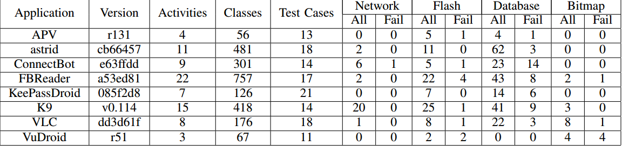

It is interesting to note the developers of these applications appear to be quite careful in their handling of network operations: since such operations are widely-known to be harmful to responsiveness, developers do not include them in the UI thread (only one ANR-triggering operation was related to the network). The other sources of jank are more prevalent, with database accesses being the most common ones .